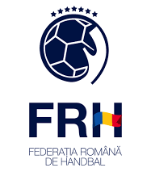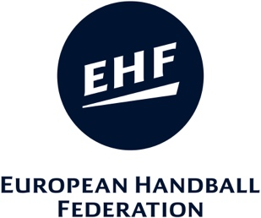
Master Coach Romania 2019-2020
License Renewal Course
23 – 26 January 2023

Registration / Confirmation

Name:
Address:
Country:
Name of your Club/Federation:
Maser Coach Diploma: | (scan/photo Master Coach Diploma)
Date of MC diploma release:
Description of your function:
Mobile phone:
E-mail address:
Billing details:

Accommodation info |  | Name of the hotel  (see invitation letter) | Royal Classic Hotel
please tick  as appropriate | No hotel: | Hotel (double bed room): |  | Hotel (single bed room):
Schedule: |  | Arrival Day: |  | Departure Day:

Please return to RHF until | 6 ianuarie 2023 E-mail: andreea.sandulescu@frh.ro

Date | Signature

